Write a query to create foreign keys for AGENT_ID and POLICY_ID in the T_MEMBER table. The AGENT_ID must refer the column in table T_AGENT and POLICY_ID must refer the column in table T_POLICY.

**Note:** The ER diagram shows the futuristic relationship between T_MEMBER, T_POLICY and T_AGENT tables. The constraint you would create as part of requirement, will ensure that the described relationship will be created.

(Note: Evaluate only the respective DDLquery to get the desired result)

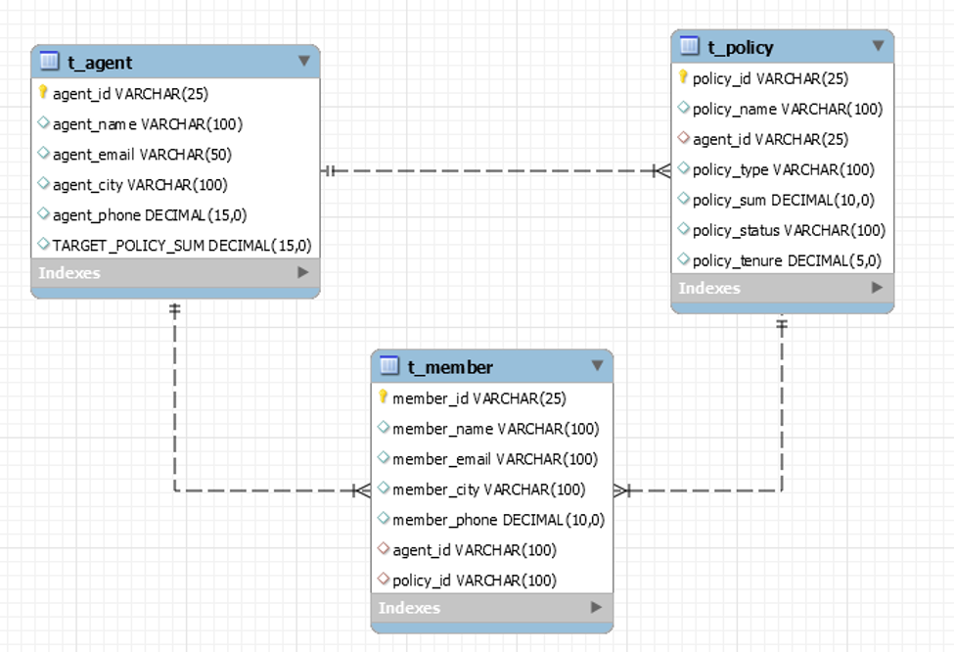

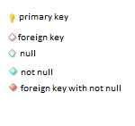

create database test;

use test;

create table t_agent(

agent_id varchar(25) primary key,

agent_name varchar(50),

agent_email varchar(50),

agent_city varchar(100),

agent_phone decimal(15,0),

TARGET_POLICY_SUM DECIMAL(15,0)

);

create table t_member(

member_id varchar(25) primary key,

member_name varchar(100),

member_email varchar(100),

member_city varchar(100),

member_phone decimal(10,0),

agent_id varchar(100),

policy_id varchar(100)

);

create table t_policy(

policy_id varchar(25) primary key,

policy_name varchar(100),

agent_id varchar(25),

policy_type varchar(100),

policy_sum decimal(10,0),

policy_status varchar(100),

policy_tenure decimal(5,0)

);

alter table t_member

add foreign key(agent_id)references t_agent(agent_id),

add foreign key(policy_id)references t_policy(policy_id);